Chapter 2

PARTS OF HUMANOID ROBOT (ALUMINOID)

- Arduino Uno R3 based Bluetooth + USB 18 Servo Controller
- Lithium Polymer ( Li-Po) Rechargeable Battery 7.4V 1500mAH 20C
- Metal Gear Standard Servo Economy
- Multipurpose Aluminum Standard Servo Bracket
- Short U Shape Aluminum Servo Bracket
- Long U Aluminum Servo Bracket
- Oblique U Shape Aluminum Servo Bracket
- Interconnect Aluminum Servo Bracket
- L Shaped Interconnect Servo Bracket
- Large U Beam Aluminum Servo Bracket
- Robot feet Aluminum Servo Bracket
- Miniature Ball Radial Bearing
- Metal Horn for Servo 25T
- Screw and screw cap set
- Ultrasonic sensor

2.1 Arduino Uno R3 based Bluetooth + USB 18 Servo Controller:
Arduino Uno R3 based Bluetooth + USB 18 Servo Controller is variant of our USB servo controller for wireless applications. This device can be operated wirelessly on Bluetooth or through USB connection. This also means that it can receive signals from any devices like PCs, Laptops, Mobile phones with Bluetooth and Java, Android and windows smartphones etc. Arduino Uno R3 based Bluetooth + USB 18 Servo Controller is ideal for making Autonomous and PC based systems which run over Hobby Servo motors. The software helps to develop the complex sequences in real time on the hardware like robotic arms, walkers, bipeds and any other servo controlled system. It also generates Arduino based code for the developed sequence which can be deployed on the controller on board thereby making the robot autonomous.
The compact module measures just 80 mm X 47 mm, and it offers both USB and asynchronous serial (UART) connectivity. No features are compromised for the small size, as our USB controller supports independent speed and range settings for each servo while delivering 0.5-microsecond resolution for smooth output across its broad output pulse range of 500 through 2500 microseconds.
Servo motor configurations like Centre, Offsets, Maximum, Minimum, servo directions and speed can be individually set. The servo configurations set can be saved to the on board controller. Additionally servo sequence functions can be created through software itself. Moreover Groups of servos can be rotated simultaneously for creating accurate and easy angular movements.
The board holds two chips configured as Master and Slave. Major servo motor positioning and servo related calculations are done by the salve chip. The Master chip i.e. Atmega 328 which is preloaded with Arduino Uno boot loader communicates with the software serially and send commands to the slave chip through I2C making the Master CPU available for other tasks. Various sensor and wireless devices like TSOP-1738 etc can be interfaced with the master making the robot wirelessly controlled.
When installed, the USB servo controller appears as a serial port to the host computer. Programming is therefore as easy as sending commands to a serial port, and as an added benefit, the servo controller is compatible with many existing programs. The servo controller is compatible with USB 1.1 and USB 2.0 standards, and driver support will initially be available for Windows 98 through Windows 8.
With its Bluetooth, USB and UART interface, the servo controller can at first be used with a PC to quickly develop motion sequences with the advantage of graphical interfaces and quick program changes.
This Robokits Arduino Uno R3 based USB 18 Servo Controller provides one of the most simple, small, and economical alternatives to standard serial servo controllers.
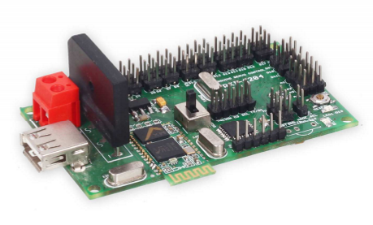
Fig:- 2.1 (ARDUNIO CIRCUIT BOARD)

2.2 Specifications of Arduino circuit:

- Bluetooth interface for wireless control of robots
- Controls 18 hobby servos from PC and Microcontroller
- USB interface
- Comes Pre-loaded Arduino Uno boot loader
- Software exports servo sequences to Arduino Uno for running servo sequences
- Independent range setting for each servo
- Independent offset, Maximum, Minimum and Direction setting for each servo
- 0.5-microsecond resolution
- 50 Hz update rate
- Small size of 80 X 47 mm
- Plug and Play, Auto detection of hardware
- Easy to use software
- Servo sequencer with speed, delay, go to and many other features
- Home and neutral position setting
- Easy to install USB driver and Application software

2.3 Elements of Arduino Circuits:

- USB Connector for connecting USB Cable to PC
- Power Connector 5 - 7.5 V DC
- Switch for Switching Between Bluetooth and USB Mode.
- Bluetooth Module (Only with RKI - 1252)
- Bluetooth Status LED
- LED on Pin 13 of Circuit Board as in Arduino
- Reset Switch

2.3.1 Power (USB / Barrel Jack):
Every Arduino board needs a way to be connected to a power source. The Arduino UNO can be powered from a USB cable coming from your computer or a wall power supply (like this) that is terminated in a barrel jack. The USB connection is also how you will load code onto your Arduino board.
NOTE: Do NOT use a power supply greater than 20 Volts as you will overpower (and thereby destroy) you’re Arduino. The recommended voltage for most Arduino models is between 6 and 12 Volts
2.3.2 Pins (5V, 3.3V, GND, Analog, Digital, PWM, and AREF):
The pins on your Arduino are the places where you connect wires to construct a circuit probably in conjunction with a breadboard and some wire. They usually have black plastic ‘headers’ that allow you to just plug a wire right into the board. The Arduino has several different kinds of pins, each of which is labeled on the board and used for different functions.
- GND: Short for ‘Ground’. There are several GND pins on the Arduino, any of which can be used to ground your circuit.
- 5V (4) & 3.3V: As you might guess, the 5V pin supplies 5 volts of power, and the 3.3V pin supplies 3.3 volts of power. Most of the simple components used with the Arduino run happily off of 5 or 3.3 volts.
- Analog: The area of pins under the ‘Analog In’ label (A0 through A5 on the UNO) are Analog In pins. These pins can read the signal from an analog sensor (like a temperature sensor) and convert it into a digital value that we can read.
- Digital: Across from the analog pins are the digital pins (0 through 13 on the UNO). These pins can be used for both digital input (like telling if a button is pushed) and digital output (like powering an LED).
- PWM: You may have noticed the tilde (~) next to some of the digital pins (3, 5, 6, 9, 10, and 11 on the UNO). These pins act as normal digital pins, but can also be used for something called Pulse-Width Modulation (PWM).
- AREF: Stands for Analog Reference. Most of the time you can leave this pin alone. It is sometimes used to set an external reference voltage (between 0 and 5 Volts) as the upper limit for the analog input pins.
2.3.3 Reset Button:
Just like the original Nintendo, the Arduino has a reset button. Pushing it will temporarily connect the reset pin to ground and restart any code that is loaded on the Arduino. This can be very useful if your code doesn’t repeat, but you want to test it multiple times. Unlike the original Nintendo however, blowing on the Arduino doesn’t usually fix any problems.
2.3.4 Power LED Indicator:
Just beneath and to the right of the word “UNO” on your circuit board, there’s a tiny LED next to the word ‘ON’. This LED should light up whenever you plug your Arduino into a power source. If this light doesn’t turn on, there’s a good chance something is wrong. Time to re-check your circuit.
2.3.5 TX RX LEDs:
TX is short for transmit, RX is short for receive. These markings appear quite a bit in electronics to indicate the pins responsible for serial communication. In our case, there are two places on the Arduino UNO where TX and RX appear – once by digital pins 0 and 1, and a second time next to the TX and RX indicator LEDs. These LEDs will give us some nice visual indications whenever our Arduino is receiving or transmitting data (like when we’re loading a new program onto the board).

2.3.6 Main IC:
The black thing with all the metal legs is an IC, or Integrated Circuit. Think of it as the brains of our Arduino. The main IC on the Arduino is slightly different from board type to board type, but is usually from the ATmega line of IC’s from the ATMEL Company. This can be important, as you may need to know the IC type (along with your board type) before loading up a new program from the Arduino software. This information can usually be found in writing on the top side of the IC. If you want to know more about the difference between various IC’s, reading the datasheets is often a good idea.
2.3.7 Voltage Regulator:
The voltage regulator is not actually something you can (or should) interact with on the Arduino. But it is potentially useful to know that it is there and what it’s for. The voltage regulator does exactly what it says – it controls the amount of voltage that is let into the Arduino board. Think of it as a kind of gatekeeper; it will turn away an extra voltage that might harm the circuit. Of course, it has its limits, so don’t hook up your Arduino to anything greater than 20 volts.

2.4 Specifications of Microcontrollers Basically used in Arduino Circuit:

- ATmega328 (used on most recent boards)
Digital I/O Pins | 14 (of which 6 provide PWM output)
Analog Input Pins | 6 (DIP) or 8 (SMD)
DC Current per I/O Pin | 40 mA
Flash Memory | 32 KB
SRAM | 2 KB
EEPROM | 1KB

- ATmega168 (used on most Arduino Diecimila and early Duemilanove)
Digital I/O Pins | 14 (of which 6 provide PWM output)
Analog Input Pins | 6 (DIP) or 8 (SMD)
DC Current per I/O Pin | 40 mA
Flash Memory | 16 KB
SRAM | 1 KB
EEPROM | 512 bytes
- ATmega8 (used on some older board)
Digital I/O Pins | 14 (of which 3 provide PWM output)
Analog Input Pins | 6
DC Current per I/O Pin | 40 mA
Flash Memory | 8 KB
SRAM | 1 KB
EEPROM | 512 bytes
2.5 Properties & Specifications of Pins Uses in Arduino Circuit:

2.5.1 Digital Pins:
The digital pins on an Arduino board can be used for general purpose input and output via the Pin Mode, Digital Read, and Digital Write commands. Each pin has an internal pull-up resistor which can be turned on and off using Digital Write (a value of HIGH or LOW, respectively) when the pin is configured as an input. The maximum current per pin is 40 mA.
2.5.2 Serial: 0 (RX) and 1 (TX): Used to receive (RX) and transmit (TX) TTL serial data. On the Arduino Diecimila, these pins are connected to the corresponding pins of the FTDI USB-to-TTL Serial chip. On the Arduino BT, they are connected to the corresponding pins of the WT11 Bluetooth module. On the Arduino Mini and LilyPad Arduino, they are intended for use with an external TTL serial module (e.g. the Mini-USB Adapter).
2.5.3 External Interrupts: 2 and 3. These pins can be configured to trigger an interrupt on a low value, a rising or falling edge, or a change in value. See the Attach Interrupt function for details.
2.5.4 PWM: 3, 5, 6, 9, 10, and 11. Provide 8-bit PWM output with the Analog Write function. On boards with an ATmega8, PWM output is available only on pins 9, 10, and 11.
2.5.5 BT Reset: 7. (Arduino BT-only) Connected to the reset line of the Bluetooth module.
2.5.6 SPI: 10 (SS), 11 (MOSI), 12 (MISO), 13 (SCK). These pins support SPI communication, which, although provided by the underlying hardware, is not currently included in the Arduino language.
2.5.7 LED: 13. On the Diecimila and LilyPad, there is a built-in LED connected to digital pin 13. When the pin is HIGH value, the LED is on, when the pin is LOW, it's off.
2.5.8 Analog Pins:
The analog input pins support 10-bit analog-to-digital conversion (ADC) using the Analog Read function. Most of the analog inputs can also be used as digital pins: analog input 0 as digital pin 14 through analog input 5 as digital pin 19. Analog inputs 6 and 7 (present on the Mini and BT) cannot be used as digital pins.
2.5.9 Power Pins:
- VIN (sometimes labelled "9V"): The input voltage to the Arduino board when it's using an external power source (as opposed to 5 volts from the USB connection or other regulated power source). You can supply voltage through this pin, or, if supplying voltage via the power jack, access it through this pin. Note that different boards accept different input voltages ranges, please see the documentation for your board. Also note that the LilyPad has no VIN pin and accepts only a regulated input.
- 5V: The regulated power supply used to power the microcontroller and other components on the board. This can come either from VIN via an on-board regulator, or be supplied by USB or another regulated 5V supply.
- 3V3: (Diecimila-only) A 3.3 volt supply generated by the on-board FTDI chip.
GND. Ground pins.

2.6 Connecting servos to Controller through Arduino:

Table 2.1:- General wire colour description for servo
All standard servo motors have 3 wire connector for connecting to any device. 2 Wires are for
Power that is VDD and GND, VDD is +4.8V to 6V (Max 7V) GND is for Ground. General wire colours are as follow:

Signal | VDD (+4.8 V DC to 7 V DC) | GND
White | Red | Black
Orange | Red | Brown
Yellow | Red/Orange | Black/Brown
Orange | Red | Black
Blue | Red | Black

2.6.1 Arduino UNO: The Arduino Uno is a microcontroller board based on the ATmega328 (datasheet). It has 14 digital input/output pins (of which 6 can be used as PWM outputs), 6 analog inputs, a 16 MHz crystal oscillator, a USB connection, a power jack, an ICSP header, and a reset button.

2.7 Lithium Polymer (Li-Po) Rechargeable Battery 7.4V 1500mAH 20C: Lithium-Polymer (Li-Po) Battery for robotic applications. It can give great instantaneous discharge current up to 30A. Very light weight and small size compared to Ni-Cd, Ni-MH and Lead acid batteries. Very long life without losing charging capacity. Weighs just 94 gm.
2.7.1 Precautions: Li-Ion batteries are very sensitive and can get damaged easily and permanently if not used properly. Charging batteries with non-standard chargers will ensure reduction in battery life and efficiency. We strongly recommend to charge battery with our chargers or only standard chargers designed to charge Li-Ion batteries. If the batteries are drained beyond their discharge capacity they will get heated and will get damaged permanently. Each battery is rated for discharge current. If the battery is rated at 2000mAH, 2C it means that it can discharge 4 Ampere (2000ma x 2) current at max. If the load is above 4A the battery will heat up and loose its efficiency to store charge over a period. Over discharging of battery may also create problem. If the voltage of battery reduces to 3.5V per cell (i.e. 10.5V or below for 12.4V battery) the battery is considered discharged. If still battery is connected the battery may get damaged.
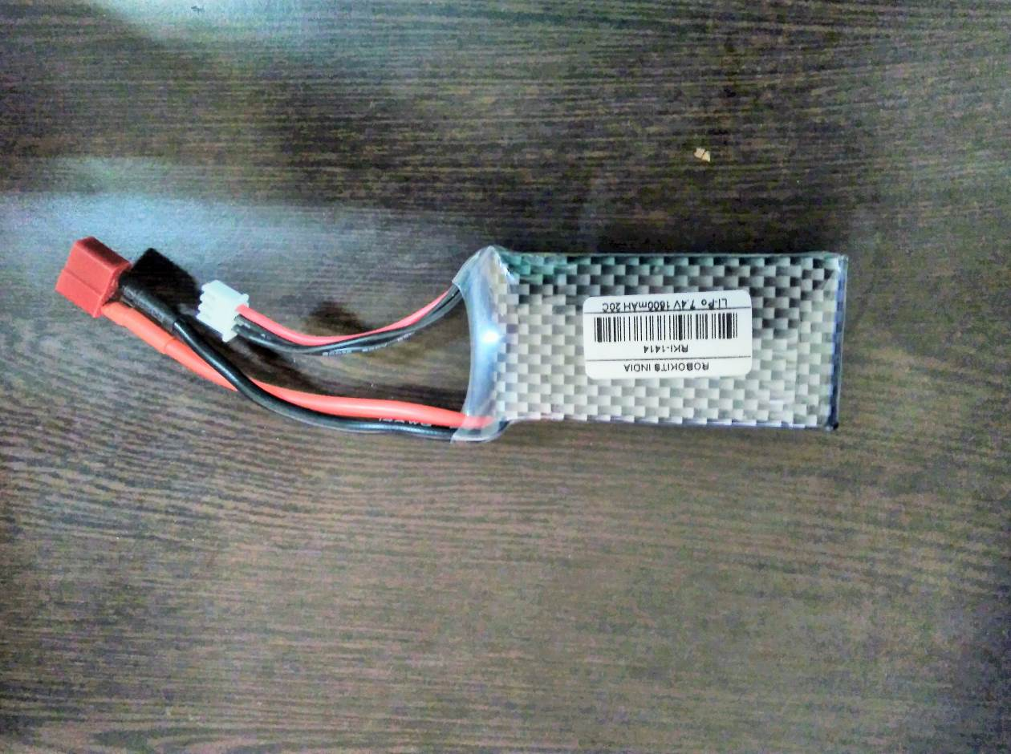
Fig: - 2.2 (Lithium Polymer Battery)
2.7.2 Specifications:
- Very Small in size and weight compared to Ni-Cd, Ni-MH and Lead Acid Batteries
- Full Charge in 180 minutes with special charger
- Long life with full capacity for up to 1000 charge cycles
- 2X Li-Po 3.7V 1500mAh cells (2S1P)
- Low maintenance
- 94Grams Weight
- Volume: 7.2cm*3.4cm*1.7cm
- Discharge Current: 20*1500maH = 30Amp
- Max Charging Current: 1A
2.7.3 Compatible chargers:

- IMAX B6AC 5A Multipurpose Battery Charger
- IMAX B6 5A Multipurpose Battery Charger
- Li-Ion / Li-Po Intelligent Fast Charger for 2-3 Cell Battery

2.8 Metal Gear Standard Servo Economy of ALUMINA: High Torque Standard Servo Motor with Metal Gears. Provides 11kg/cm at 4.8V, 13.5kgcm at 6V and 16kg/cm at 7.2V.
2.8.1 Servomotor:
A servo motor is an electrical device which can push or rotate an object with great precision. If you want to rotate and object at some specific angles or distance, then you use servo motor. It is just made up of simple motor which run through servo mechanism. If motor is used is DC powered then it is called DC servo motor, and if it is AC powered motor then it is called AC servo motor. We can get a very high torque servo motor in a small and light weight packages. Doe to these features they are being used in many applications like toy car, RC helicopters and planes, Robotics, Machine etc.
Servo motors are rated in kg/cm (kilogram per centimeter) most hobby servo motors are rated at 3kg/cm or 6kg/cm or 12kg/cm. This kg/cm tells you how much weight your servo motor can lift at a particular distance. For example: A 6kg/cm Servo motor should be able to lift 6kg if the load is suspended 1cm away from the motors shaft, the greater the distance the lesser the weight carrying capacity. The position of a servo motor is decided by electrical pulse and its circuitry is placed beside the motor.
The very simplest servomotors use position-only sensing via a potentiometer and bang-bang control of their motor; the motor always rotates at full speed (or is stopped). This type of servomotor is not widely used in industrial motion control, but it forms the basis of the simple and cheap servos used for radio-controlled models.
More sophisticated servomotors use optical rotary encoders to measure the speed of the output shaft and a variable-speed drive to control the motor speed. Both of these enhancements, usually in combination with a PID control algorithm, allow the servomotor to be brought to its commanded position more quickly and more precisely, with less overshooting.
2.8.2 Servo Mechanism:
It consists of three parts:
- Controlled device
- Output sensor
- Feedback system
It is a closed loop system where it uses positive feedback system to control motion and final position of the shaft. Here the device is controlled by a feedback signal generated by comparing output signal and reference input signal.
Here reference input signal is compared to reference output signal and the third signal is produces by feedback system. And this third signal acts as input signal to control device. This signal is present as long as feedback signal is generated or there is difference between reference input signal and reference output signal. So the main task of servomechanism is to maintain output of a system at desired value at presence of noises.
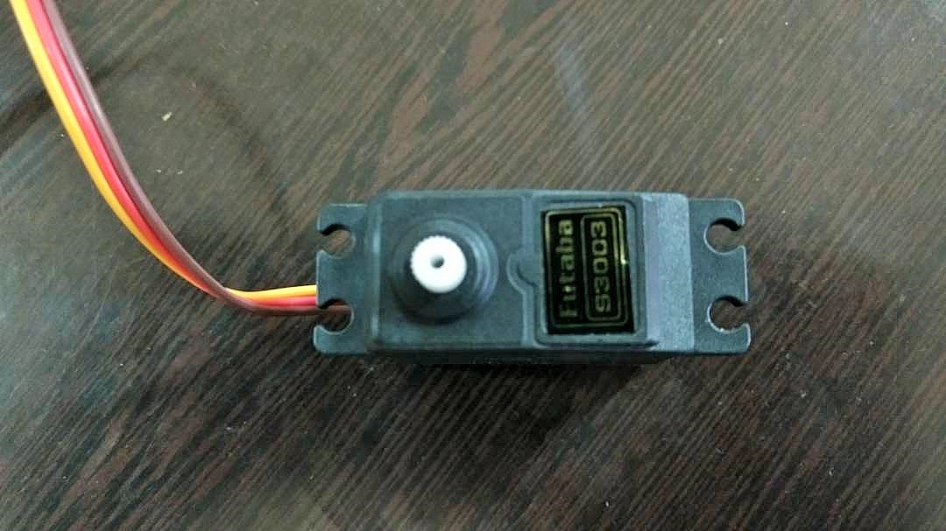
Fig: - 2.3 (Servomotor)

2.8.3 Working principle of Servo Motors:
A servo consists of a Motor (DC or AC), a potentiometer, gear assembly and a controlling circuit. First of all we use gear assembly to reduce RPM and to increase torque of motor. Say at initial position of servo motor shaft, the position of the potentiometer knob is such that there is no electrical signal generated at the output port of the potentiometer. Now an electrical signal is given to another input terminal of the error detector amplifier. Now difference between these two signals, one comes from potentiometer and another comes from other source, will be processed in feedback mechanism and output will be provided in term of error signal. This error signal acts as the input for motor and motor starts rotating. Now motor shaft is connected with potentiometer and as motor rotates so the potentiometer and it will generate a signal. So as the potentiometer’s angular position changes, its output feedback signal changes. After sometime the position of potentiometer reaches at a position that the output of potentiometer is same as external signal provided. At this condition, there will be no output signal from the amplifier to the motor input as there is no difference between external applied signal and the signal generated at potentiometer, and in this situation motor stops rotating
2.8.4 Controlling Servo Motor:
All motors have three wires coming out of them. Out of which two will be used for Supply (positive and negative) and one will be used for the signal that is to be sent from the MCU.
Servo motor is controlled by PWM (Pulse with Modulation) which is provided by the control wires. There is a minimum pulse, a maximum pulse and a repetition rate. Servo motor can turn 90 degree from either direction form its neutral position. The servo motor expects to see a pulse every 20 milliseconds (ms) and the length of the pulse will determine how far the motor turns. For example, a 1.5ms pulse will make the motor turn to the 90° position, such as if pulse is shorter than 1.5ms shaft moves to 0° and if it is longer than 1.5ms than it will turn the servo to 180°.
Servo motor works on PWM (Pulse width modulation) principle, means its angle of rotation is controlled by the duration of applied pulse to its Control PIN. Basically servo motor is made up of DC motor which is controlled by a variable resistor (potentiometer) and some gears. High speed force of DC motor is converted into torque by Gears. We know that WORK= FORCE X DISTANCE, in DC motor Force is less and distance (speed) is high and in Servo, force is High and distance is less. Potentiometer is connected to the output shaft of the Servo, to calculate the angle and stop the DC motor on required angle.
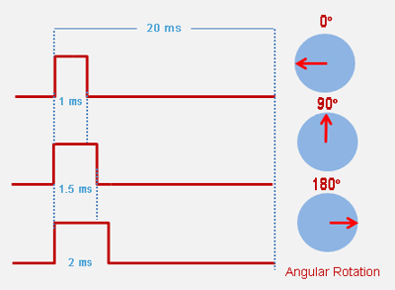
Fig: - 2.4 (Servomotor pulse)
Servo motor can be rotated from 0 to 180 degree, but it can go up to 210 degree, depending on the manufacturing. This degree of rotation can be controlled by applying the Electrical Pulse of proper width, to its Control pin. Servo checks the pulse in every 20 milliseconds. Pulse of 1 ms (1 millisecond) width can rotate servo to 0 degree, 1.5ms can rotate to 90 degree (neutral position) and 2 ms pulse can rotate it to 180 degree.
All servo motors work directly with your +5V supply rails but we have to be careful on the amount of current the motor would consume, if you are planning to use more than two servo motors a proper servo shield should be designed.

2.8.5 Servo Specifications of ALUMINA:-
- Required Pulse: 3-5 Volt Peak to Peak Square Wave
- Operating Voltage: 4.8-7.2 Volts
- Operating Temperature Range: -10 to +60 Degree C
- Operating Speed (4.8V): 0.18sec/60 degrees at no load
- Operating Speed (6V): 0.16sec/60 degrees at no load
- Operating Speed (7.2V): 0.14sec/60 degrees at no load
- Stall Torque (4.8V): 11kg/cm
- Stall Torque (6V): 13.5kg/cm
- Stall Torque (7.2V): 16kg/cm
- 360 Modifiable: Yes
- Potentiometer Drive: Indirect Drive
- Bearing Type: Double Ball Bearing
- Gear Type: All Metal Gears
- Connector Wire Length: 12"
- Dimensions: 1.6" x 0.8"x 1.4" (41 x 20 x 36mm)
- Weight: 56gm

2.8.6 Servo Controlling of Features of ALUMINA:-
- Bluetooth interface for wireless control of robots
- Controls 18 hobby servos from PC and Microcontroller
- USB interface
- Comes Pre-loaded Arduino Uno boot loader
- Software exports servo sequences to Arduino Uno for running servo sequences
- Independent range setting for each servo
- Independent offset, Maximum, Minimum and Direction setting for each servo
- 0.5-microsecond resolution
- 50 Hz update rate
- Small size of 80 X 47 mm
- Plug and Play, Auto detection of hardware
- Easy to use software
- Servo sequencer with speed, delay, go to and many other features
- Home and neutral position setting

2.9 Multipurpose Aluminum Standard Servo Bracket: -
Aluminum Pan and Tilt for horizontal surface, unassembled, Pan and Tilt Mount Servo Stand for Robot Clamp Claw, Servo bracket used in the shoulders and knees or other joint of humanoid robots, biped robots etc.
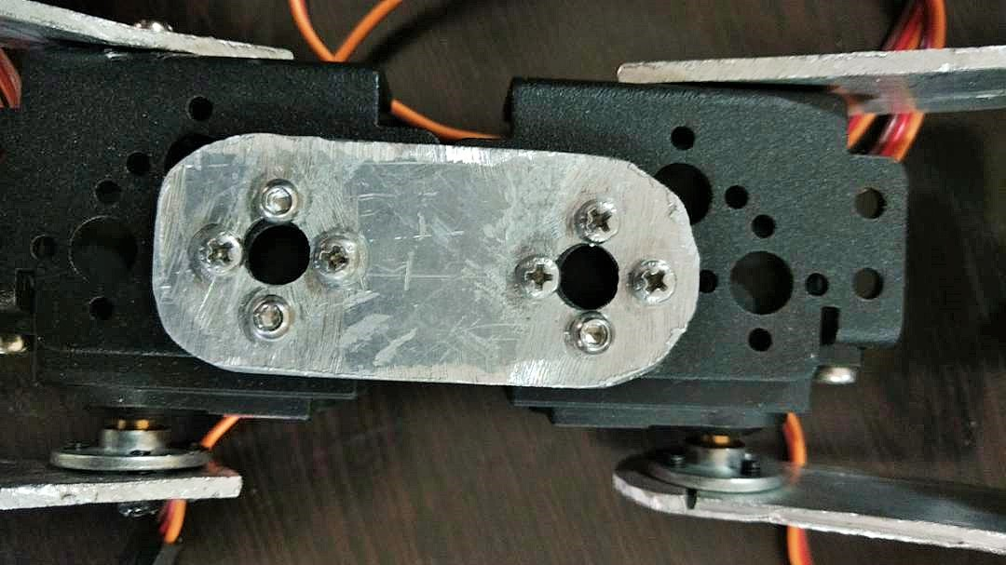
Fig: - 2.5 (Servo Bracket)
2.10 Short U Shape Aluminum Servo Bracket: -
This Short 'U' shaped brackets is designed to fit most standard sized servos. This bracket is both lightweight and strong. Various holes are located on the bracket that fit most servo horns.
These brackets are light and strong and the numerous mounting holes enable you to easily make custom mechanisms using standard servo motors. Works great for making multi-axis joints for use in robot arms and legs.
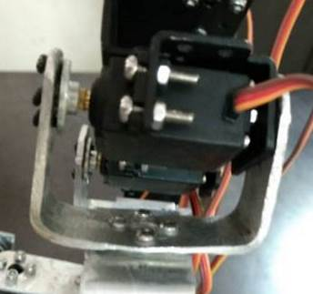
Fig: - 2.6 (Short U Clamp)
2.11 Long U Aluminum Servo Bracket: -
This Long 'U' shaped brackets is designed to fit most standard sized servos. This bracket is both lightweight and strong. Various holes are located on the bracket that fit most servo horns.
These brackets are light and strong and the numerous mounting holes enable you to easily make custom mechanisms using standard servo motors. Works great for making multi-axis joints for use in robot arms and legs.
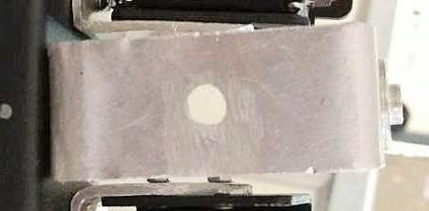
Fig: - 2.7 (Long U Clamp)
2.12 Oblique U Shape Aluminum Servo Bracket: -
This Oblique 'U' shaped brackets is designed to fit most standard sized servos. This bracket is both lightweight and strong. Various holes are located on the bracket that fit most servo horns.
These brackets are light and strong and the numerous mounting holes enable you to easily make custom mechanisms using standard servo motors. Works great for making multi-axis joints for use in robot arms and legs.
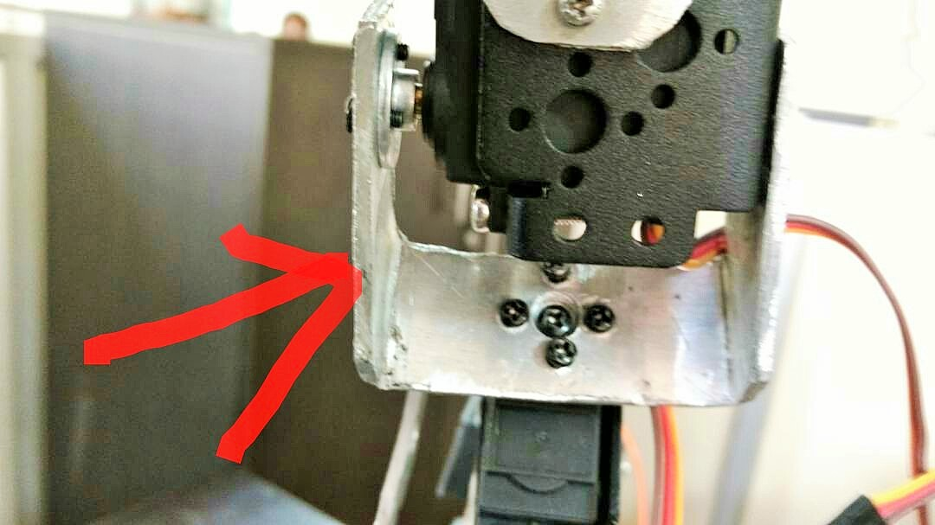
Fig: - 2.8 (Oblique Clamp for servo)
2.13 Interconnect Aluminum Servo Bracket: -
This Slotted Servo bracket straight board Mount designed to fit most standard sized servos. This bracket is both lightweight and strong. Various holes are located on the bracket that fit most servo horns.
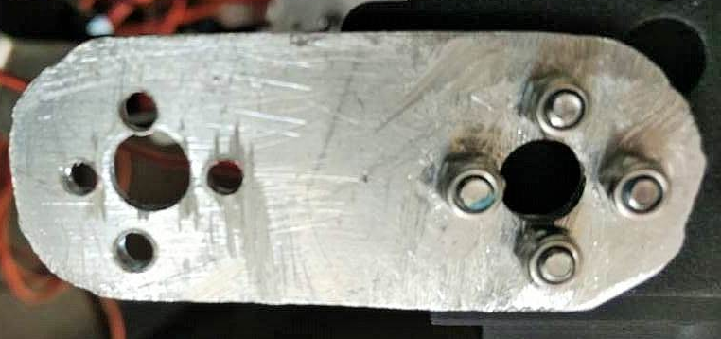
Fig: - 2.9 (Interconnected Aluminum Servo Bracket)

2.14 L Shaped Interconnect Servo Bracket: -
This 'L' shaped brackets is designed to fit most standard sized servos. This bracket is both lightweight and strong. Various holes are located on the bracket that fit most servo horns.
These brackets are light and strong and the numerous mounting holes enable you to easily make custom mechanisms using standard servo motors.
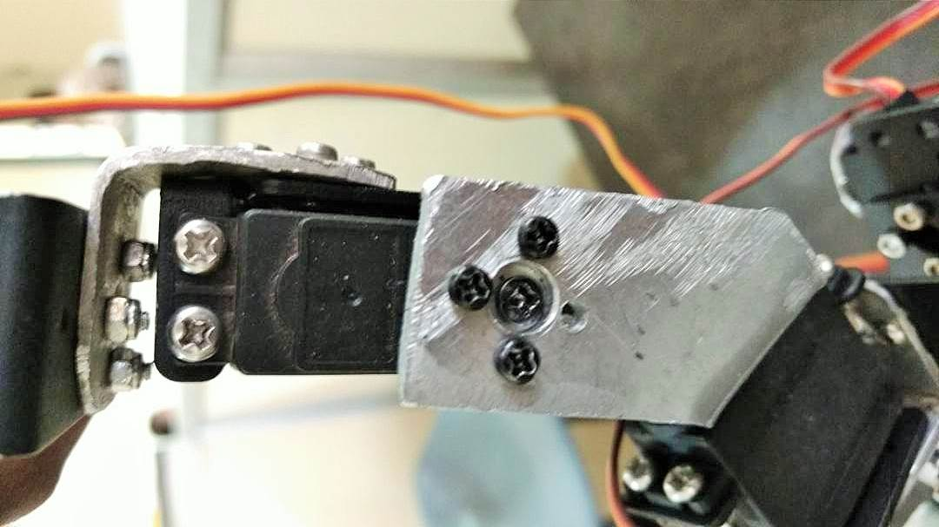
Fig: - 2.10 (L Shaped Interconnected Servo Bracket)
2.15 Large U Beam Aluminum Servo Bracket: -
This large 'U' shaped brackets is designed to fit most standard sized servos. This bracket is both lightweight and strong. Various holes are located on the bracket that fit most servo horns.
These brackets are light and strong and the numerous mounting holes enable you to easily make custom mechanisms using standard servo motors.
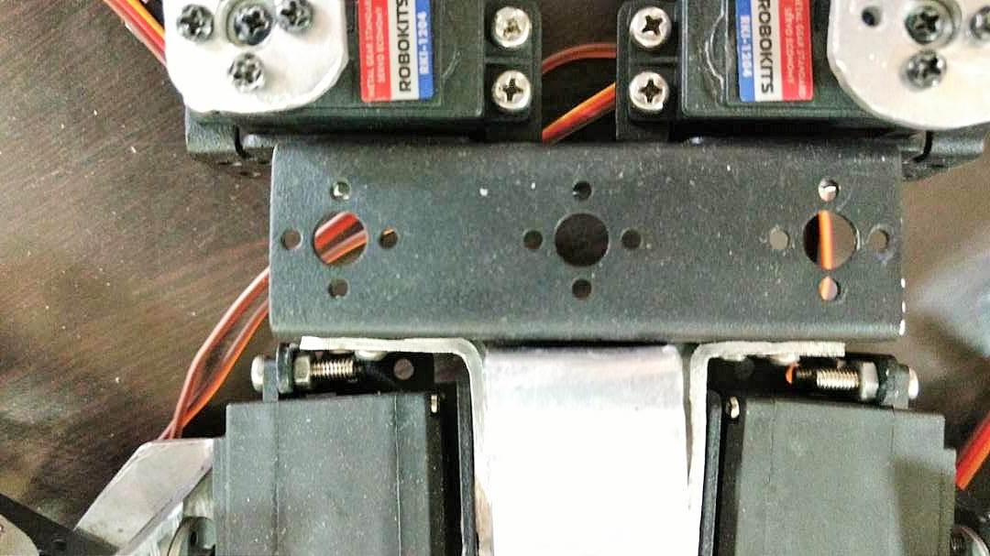
Fig: - 2.11 (Large U Beam Aluminum Servo Bracket)

2.16 Robot feet Aluminum Servo Bracket: -
This Robot foot base mount bracket is designed to fit most standard sized servos. This bracket is both lightweight and strong.
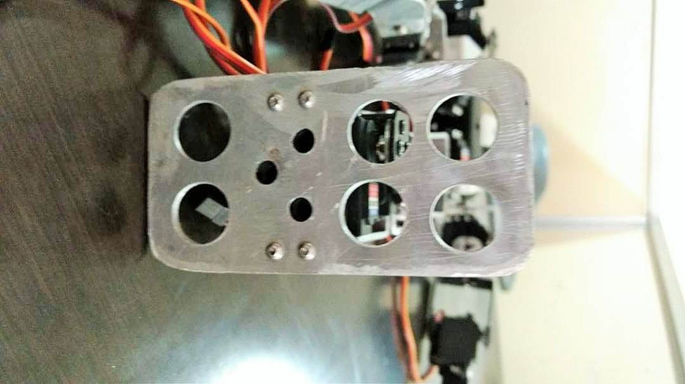
Fig: - 2.12 (Robot Feet Aluminum Servo Bracket)
2.17 Metal Horn for Servo 25T:-
Servo metal disc board 25T for servos. Compatible with RKI-1200, RKI-1206, RKI-1204, RKI-1210, RKI-1211 and HS-311 servos.
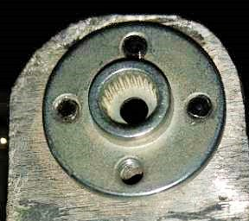
Fig: - 2.13 (Metallic Horn)

Specifications for part made up of aluminum:-
- Material: 2.5mm Hard aluminium
- Surfacing: Grinding & Filing
- Cutting: Glinder
- Drilling: Drill Machine
- Colour: Silver

2.18 Ultrasonic Sensor:-
Ultrasonic sensors “are based on the measurement of the properties of acoustic waves with frequencies above the human audible range,” often at roughly 40 kHz ¹⁾. They typically operate by generating a high-frequency pulse of sound, and then receiving and evaluating the properties of the echo pulse.
Three different properties of the received echo pulse may be evaluated, for different sensing purposes. They are:
- Time of flight (for sensing distance)
- Doppler shift (for sensing velocity)
- Amplitude attenuation (for sensing distance, directionality, or attenuation coefficient)
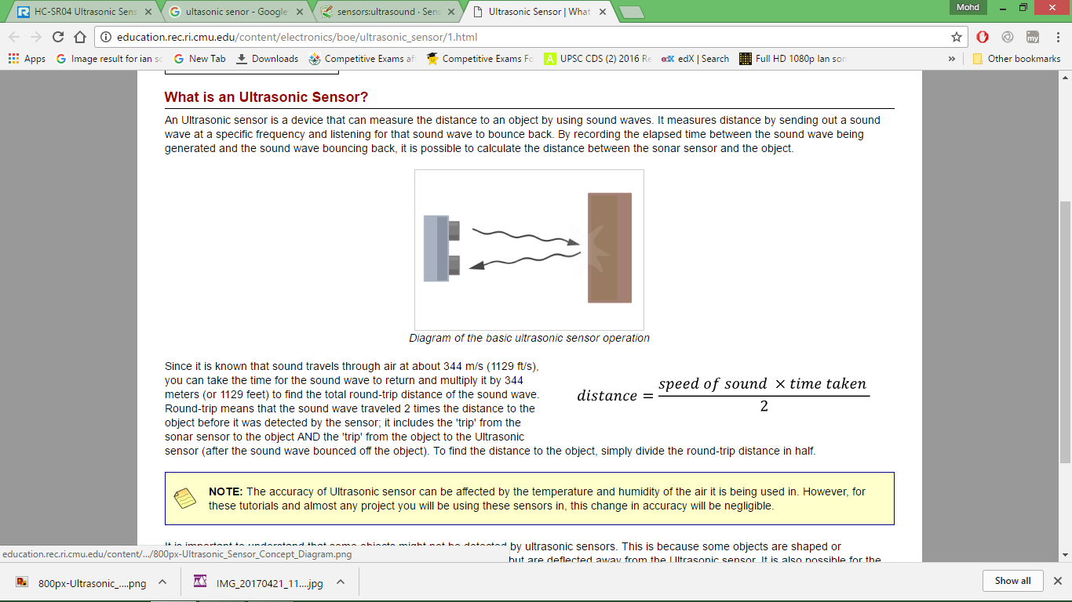
Fig:- 2.14 (Working of Ultrasonic Sensor)
This performance of the ultrasonic sensor distance measuring module is stable, measure the distance accurately. The module is with High precision, blind spots (3cm) super close. This module provides a full set of ranging process.

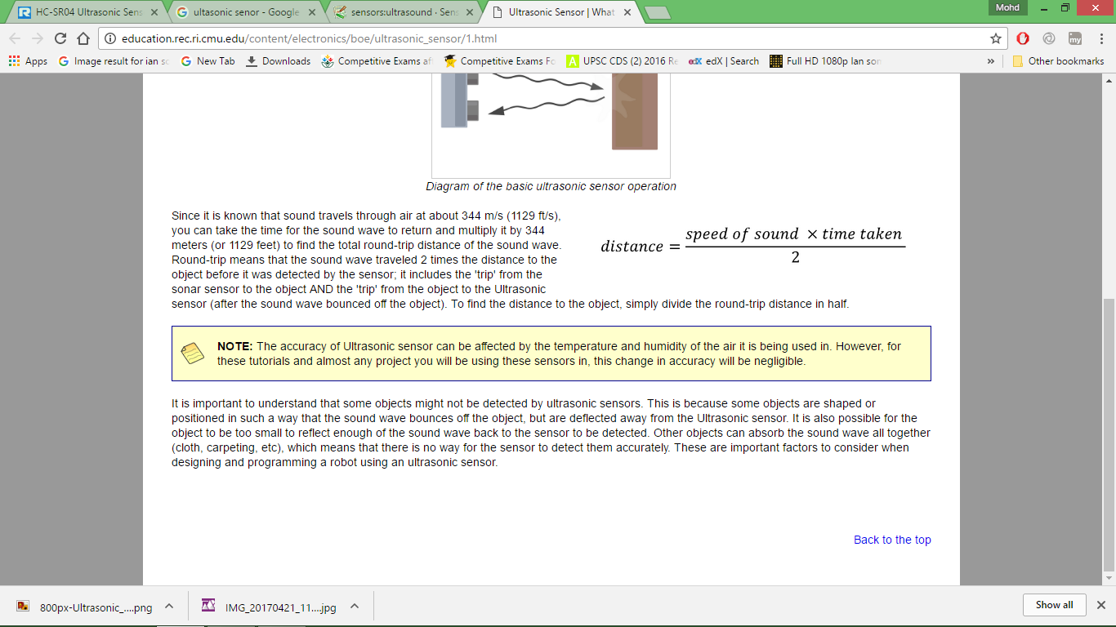

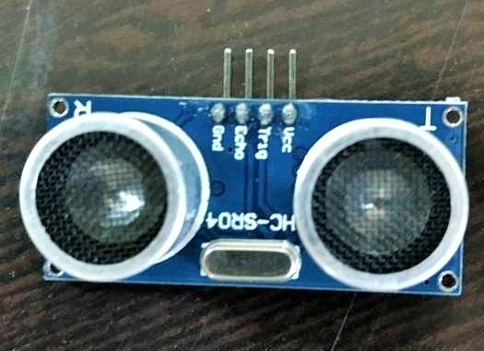
Fig: - 2.15 (Ultrasonic Sensor)

2.18.1 Difference between Infrared sensor & Ultrasonic sensor:
Table: - 2.18
Infrared Sensor | Ultrasonic Sensor
- IR sensor is an electronic instrument which is used to sense certain characteristics of its surroundings by either emitting and/or detecting infrared radiation.  - IR sensor are also capable of measuring the heat being emitted by an object and detecting motion. | - Ultrasonic sensors are almost completely insensitive to interfering factors (such as extraneous light, dust, smoke, mist, vapor, lint, oily air, etc.).  - They are best suited for the detection of transparent and dark objects, reflective surfaces, and shiny objects and of bulk materials and liquids.  - Ultrasonic sensors allow for the reliable detection and measurement of objects, independent of their material, color, transparency and texture.

Note: The fundamental difference between the sensors is that IR sensors are detecting electromagnetic radiation while ultra sound sensors are detecting mechanical or acoustical energy.
Features:
- Working voltage: 5V (DC)
- Static current: Less than 2mA.
- Output signal: Electric frequency signal, high level 5V, low level 0V.
- Sensor angle: Not more than 15 degrees.
- Detection distance: 2cm~450cm.
- High precision: Up to 3mm
- Mode of connection: VCC / trig(T) / echo(R) / GND

